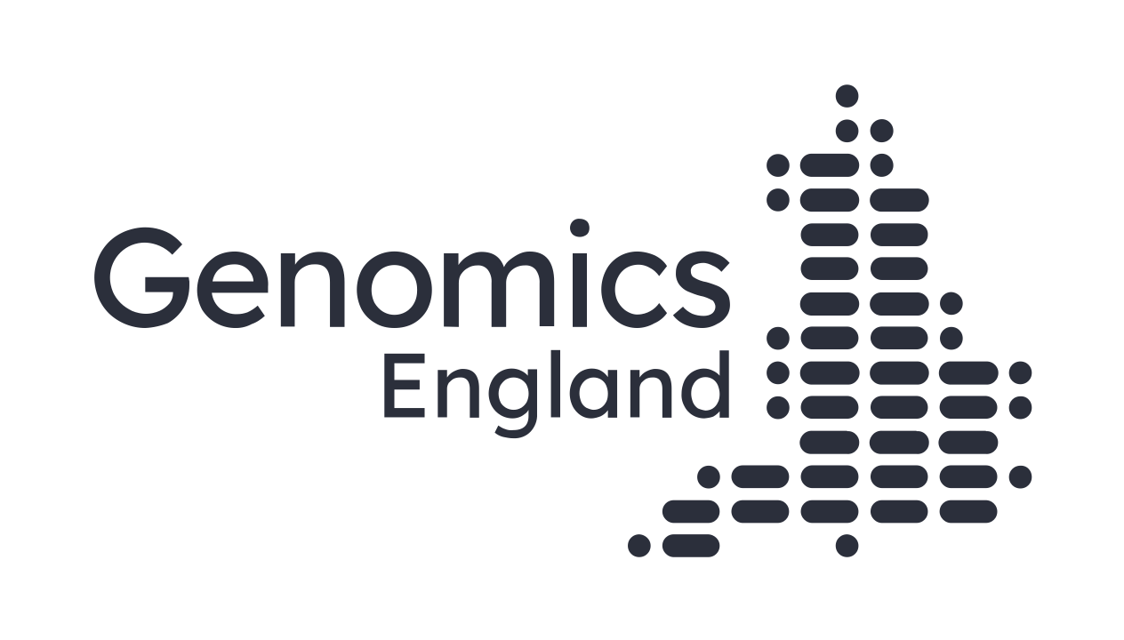
Language
and terminology
This guide, developed by the Participant Panel, recommends how to talk about the people whose data is curated at Genomics England.

2022

info@genomicsengland.co.uk | www.genomicsengland.co.uk

Table of contents
Principles 3
Table 1: Talking about disability – recommendations 6
Table 2: Talking about genomics - recommendations 6
How to talk about cancer 7
How to talk about the 100,000 Genomes Project and its participants 8
How to talk about the Participant Panel 8

Principles
This guide has been developed following a Participant Panel workshop on 8th February 2022. It sets out the Panel’s agreed recommendations on how to talk about the people whose data is curated by Genomics England. This guide is intended for use by Genomics England staff and their partner organisations across the wider genomics ecosystem.

In drawing together our recommendations, the Participant Panel has agreed a set of general principles.

Every data point has a face
Behind each data point is a person; someone who could be just like you. Everyone could be affected by a rare health condition. Rare diseases are collectively so common (1 in 17 people) that everybody will know someone who has one, although they might not talk about it. And cancer will touch most families during their lifetime (1 in 2 people).

So…

- When thinking about communicating with patients and research participants, treat everyone as you would like to be treated. Be mindful of the audience (with the cognition of an ‘intelligent 7 year-old’) and use accessible formats and accessible language.
- Respect everyone equally, regardless of how they got involved in genomics (patient, family member, professional, etc): it’s a team endeavour and we are all equally invested in its success.
- Recognise that patients and families do not always choose to define themselves or their relatives by the health conditions that brought them here: genomics research is just one aspect of their lives.
- When writing up case studies, picture the people whose data you’re talking about. Would they be happy with how you are describing them? (See Table 1 below for further advice).
- Always keep in mind that human flourishing is for all: everyone has something to contribute.
- However, don’t be afraid of saying the wrong thing; it’s always better to come and talk to patients and research participants, than to avoid it for fear of causing offence!
Drivers and differences
Those who agree to donate their data have many different reasons for doing so:
- The 100,000 Genomes Project recruited two groups: those with undiagnosed rare conditions and those with cancer.
  - ‘Rare disease’ participants signed up for diagnoses, better understanding of their conditions now and in the future, and possible treatments to alleviate their effects. Few were anticipating cures. Getting a long-awaited diagnosis creates choices about what to do with that information, where to look for treatment and also means people can link with others with the same condition, on the way to understanding it better.
  - Cancer participants had different perspectives: those who signed up already knew that they had cancer, and understood that the Project could not return genetic information in time to help them personally. Their reasons for involvement were principally altruistic.

- As WGS becomes available through the NHS Genomic Medicine Service, it is generating a set of perspectives and drivers which may be different to recruits to the 100,000 Genomes Project, e.g.
  - ‘For rare disease’ participants these may now include meeting an immediate clinical need or the opportunity to find out more about their conditions in due course.
  - Cancer patients on the other hand, now that return of results is so much quicker, are being offered the chance to look for actionable variants, which may be their main driver.

For example, those who were recruited to the 100,000 Genomes Project from the Deaf community, many don't see themselves as disabled, and would not necessarily want this to change.

Participants are not a homogenous group. They have different approaches / cultures / language fluency: don’t assume that ‘one size fits all’ in your communication with participant communities.

Know your audience: family journeys bring different stages of acceptance / grief / etc – newly diagnosed families may feel very differently to those who have been living with a condition for longer. Generally speaking, acceptance grows with time since diagnosis. But so does an awareness of stereotyping and the disabling nature of many aspects of mainstream society: the ‘social model of disability’.
Use of language
We all recognise that the same term can evoke different reactions, but there are some that should generally be avoided (see Table 1 below for details). Whilst it is understood that clinicians talking to colleagues will use scientific language amongst themselves, they should be aware that increasingly their notes are shared with patients and to be mindful of their impact that scientific language may have in other contexts.

Bear the context in mind when deciding what language to use when describing other people’s experiences: a specific diagnosis may indeed have been ‘devastating’ for the particular family in question, but the condition itself may not be so for everybody. If you have any means of checking with the participant/patient/family that you wish to present in a case study, please do ask them how they actually feel (or felt when the incident occurred) before speaking on their behalf.

Talk to people directly affected or living with a condition, and present some positive experiences when writing information for patients and parents. Medical textbooks rarely reflect the real lived experiences of people with particular conditions, by typically using a uniformly negative tone. Clinicians often repeat this same language in patient literature. This is especially alarming for newly diagnosed patients and families, who are on a voyage of discovery that they may never have anticipated but will have life-long implications.

Disabled people may choose terms to describe themselves and their own communities that are not acceptable labels when applied by outsiders; when starting to work with a particular community, take time to ascertain the terminology they’d like you / professionals / outsiders to use.

Avoid making assumptions, and using value-laden descriptions of life experience such as 'suffering', 'victims' to be ‘pitied’ etc. If you must talk about the impact of a condition, strive to use language that describes the symptoms in an objective way (e.g. the patient’s condition results in decreased hand-eye co-ordination).

Avoid sensationalising disabled people, cancer patients or their families, e.g. suggesting they’re a ‘superhero’ or ‘brave’ or ‘inspirational’ for living with these conditions. You’d probably do the same if you were in their position.

Avoid inferring or implying things about how people look, move or behave based on their DNA. Always be clear whether you are talking about the person or their unusual gene(s). Terms like ‘mutation’ are OK to use when talking about genes, but not OK when talking about a person. Please see Table 2 below for details.
Fluidity
We all recognise that acceptable uses of language evolve over time. Keep refreshing your understanding of acceptable language e.g. regularly seeking input from experts / people with lived experience of the conditions that you are working on.

Active learning: what does your audience think about what has been presented? Don’t be afraid to ask.

Please contact the Panel at any time and talk to us about language – we welcome these conversations and are happy to share our lived experiences – that’s why we are here!

Table 1: Talking about disability – recommendations

If you’re tempted to use… | Go for this instead please
Victim of | Person who has  Person with  Person who experienced
Crippled by | Disabled person  Person who has  Person with
Sufferer  Suffering from | Person who has  Person with  Affected by…?  Living with?
Afflicted  Afflicted by | Person who has  Person with
Wheelchair bound | Wheelchair user.  Wheelchair users often see them positively: they offer freedom and independence
Invalid | Disabled person
Handicap | Disability / with an impairment
Handicapped person / Person with a disability | Disabled person
Disability | Condition / impairment
Less-abled/differently-abled | Disabled people
Able-bodied | Non disabled people
The disabled | Disabled people
The blind | Blind person / people  Visually impaired
The deaf | Deaf person / people
Deaf and dumb  Deaf mute | Deaf or deafened  Hearing impaired
Disfigured | Facial disfigurement is the preferred term. No need for adjectives (severe / mild etc)
Missing limb | Limb difference
Person with autism | Autistic person (but see also NHSD guidance re: epilepsy, diabetes etc which suggests ‘a person with x’ rather than ‘an epileptic’ or ‘a diabetic’)
Mental handicap | Learning difficulty  or learning disability, depending on the severity of the condition
Mute / dumb | Speech difficulty, non-verbal, preverbal
Mad / insane | Experiencing mental ill health
Mentally ill | Experiencing mental ill health
Dwarf / Midget | Short person  Short stature
Deformity / visible difference | Disfigurement (no adjectives necessary: avoid mild / severe etc)
Congenital (condition) | Health condition present from birth

Table 2: Talking about genomics - recommendations

If you’re tempted to use…. | Please choose this instead
(Germline) mutation  …when referring to the DNA we’re born with | Preferred: (gene) variant  Possible alternatives: (gene) change, spelling mistake, alteration, glitch
(Somatic) mutation  … when used to describe changes that occur in cells throughout life, cancer, etc | Mutation or variant is OK
Dysmorphic | OK in clinical / technical context  NOT OK when talking to patients and families – e.g. instead describe features as ’unusual’
Defective (system in the body) | OK in technical context, some patients also happy with this
Genetic defect or fault (in a person) | Please avoid.  Prefer the technical language (e.g. deletion, insertion, duplication, variant)
Disease | Condition or  Disorder (especially if part of the name of the diagnosis e.g. OCD)
Normal | Typical (e.g. neurotypical)  Or ‘born without [the particular condition/variant]’, ‘born after an uneventful pregnancy’
Abnormality | Unusual / atypical  (e.g. neurodiverse)  Or ‘born with [the particular condition/variant]’
Devastating, terrible, etc. (disease) | Avoid making value judgements about other people’s experiences
‘Fixing’ people | Finding treatments for people [that could improve their quality of life]
Rare disease | Rare condition  ‘rare disease’ is commonly used, but many of us prefer ‘rare condition’
Rare syndrome | OK in medical / technical context
Exploiting data  Interrogating data  Harvesting data  Mining data | Accessing, using or analysing data
Healthy relatives (compared to proband) | (unaffected) relatives or relatives without the condition, symptom or gene variant in question

How to talk about cancer
- Don’t use war metaphors! Battling, fighting, winning etc suggest that individuals can ‘overcome’ it by force of will, which is just not true.
- Do recognise that Genomics England’s cancer cohort is made up of people with a spectrum of experiences of cancer, not all of whom are patients. They include:
  - People living with cancer
  - People who have had cancer (avoid ‘cured’ or ‘survivor’)
  - People with a cancer susceptibility gene variant (avoid ‘previvor’)

How to talk about the 100,000 Genomes Project and its participants
- Note that it’s genomes in the plural and that Genomes and Project should always be capitalised. 100kGP is acceptable on slides and internal documents. Externally it’s the 100,000 Genomes Project.
- We always talk about ‘participants’ not patients. This is because:
  - ‘Participant’ correctly implies active involvement and choice.
  - At least two thirds of our rare disease cohort are not patients – they are unaffected relatives who do not have the same condition or genetic variant.
  - Many people with rare conditions do not consider themselves as ‘patients’ which implies that they are unwell. For example, they may have hearing loss.
  - Many people previously treated for cancer or who are at risk from familial cancer syndromes do not consider themselves as ‘patients’.
- Please do not describe the 100,000 Genomes Project as ‘finished’, ‘completed’ or ‘done’. Between 75-80% of those recruited to the 100,000 Genomes Project due to a rare disease/condition have NOT had a diagnosis, although the Project has completed its recruitment and initial return phase, the quest for diagnosis continues for them and needs to remain a focus for Genomics England.

How to talk about the Participant Panel
The Participant Panel is an independent entity. It should be described as:
- the [independent] Participant Panel at Genomics England, or
- the Participant Panel, or
- the Panel.
It is not ‘the Patient Participant Panel’.
It is not ‘Genomics England’s Participant Panel’.

It is not a UK Participant Panel – it represents the people whose data is in the ‘National Genomics Research Library’ but some of the devolved nations have their own arrangements.

