­

**Contact Details to go here**  
Like this

LOGO TO GO HERE

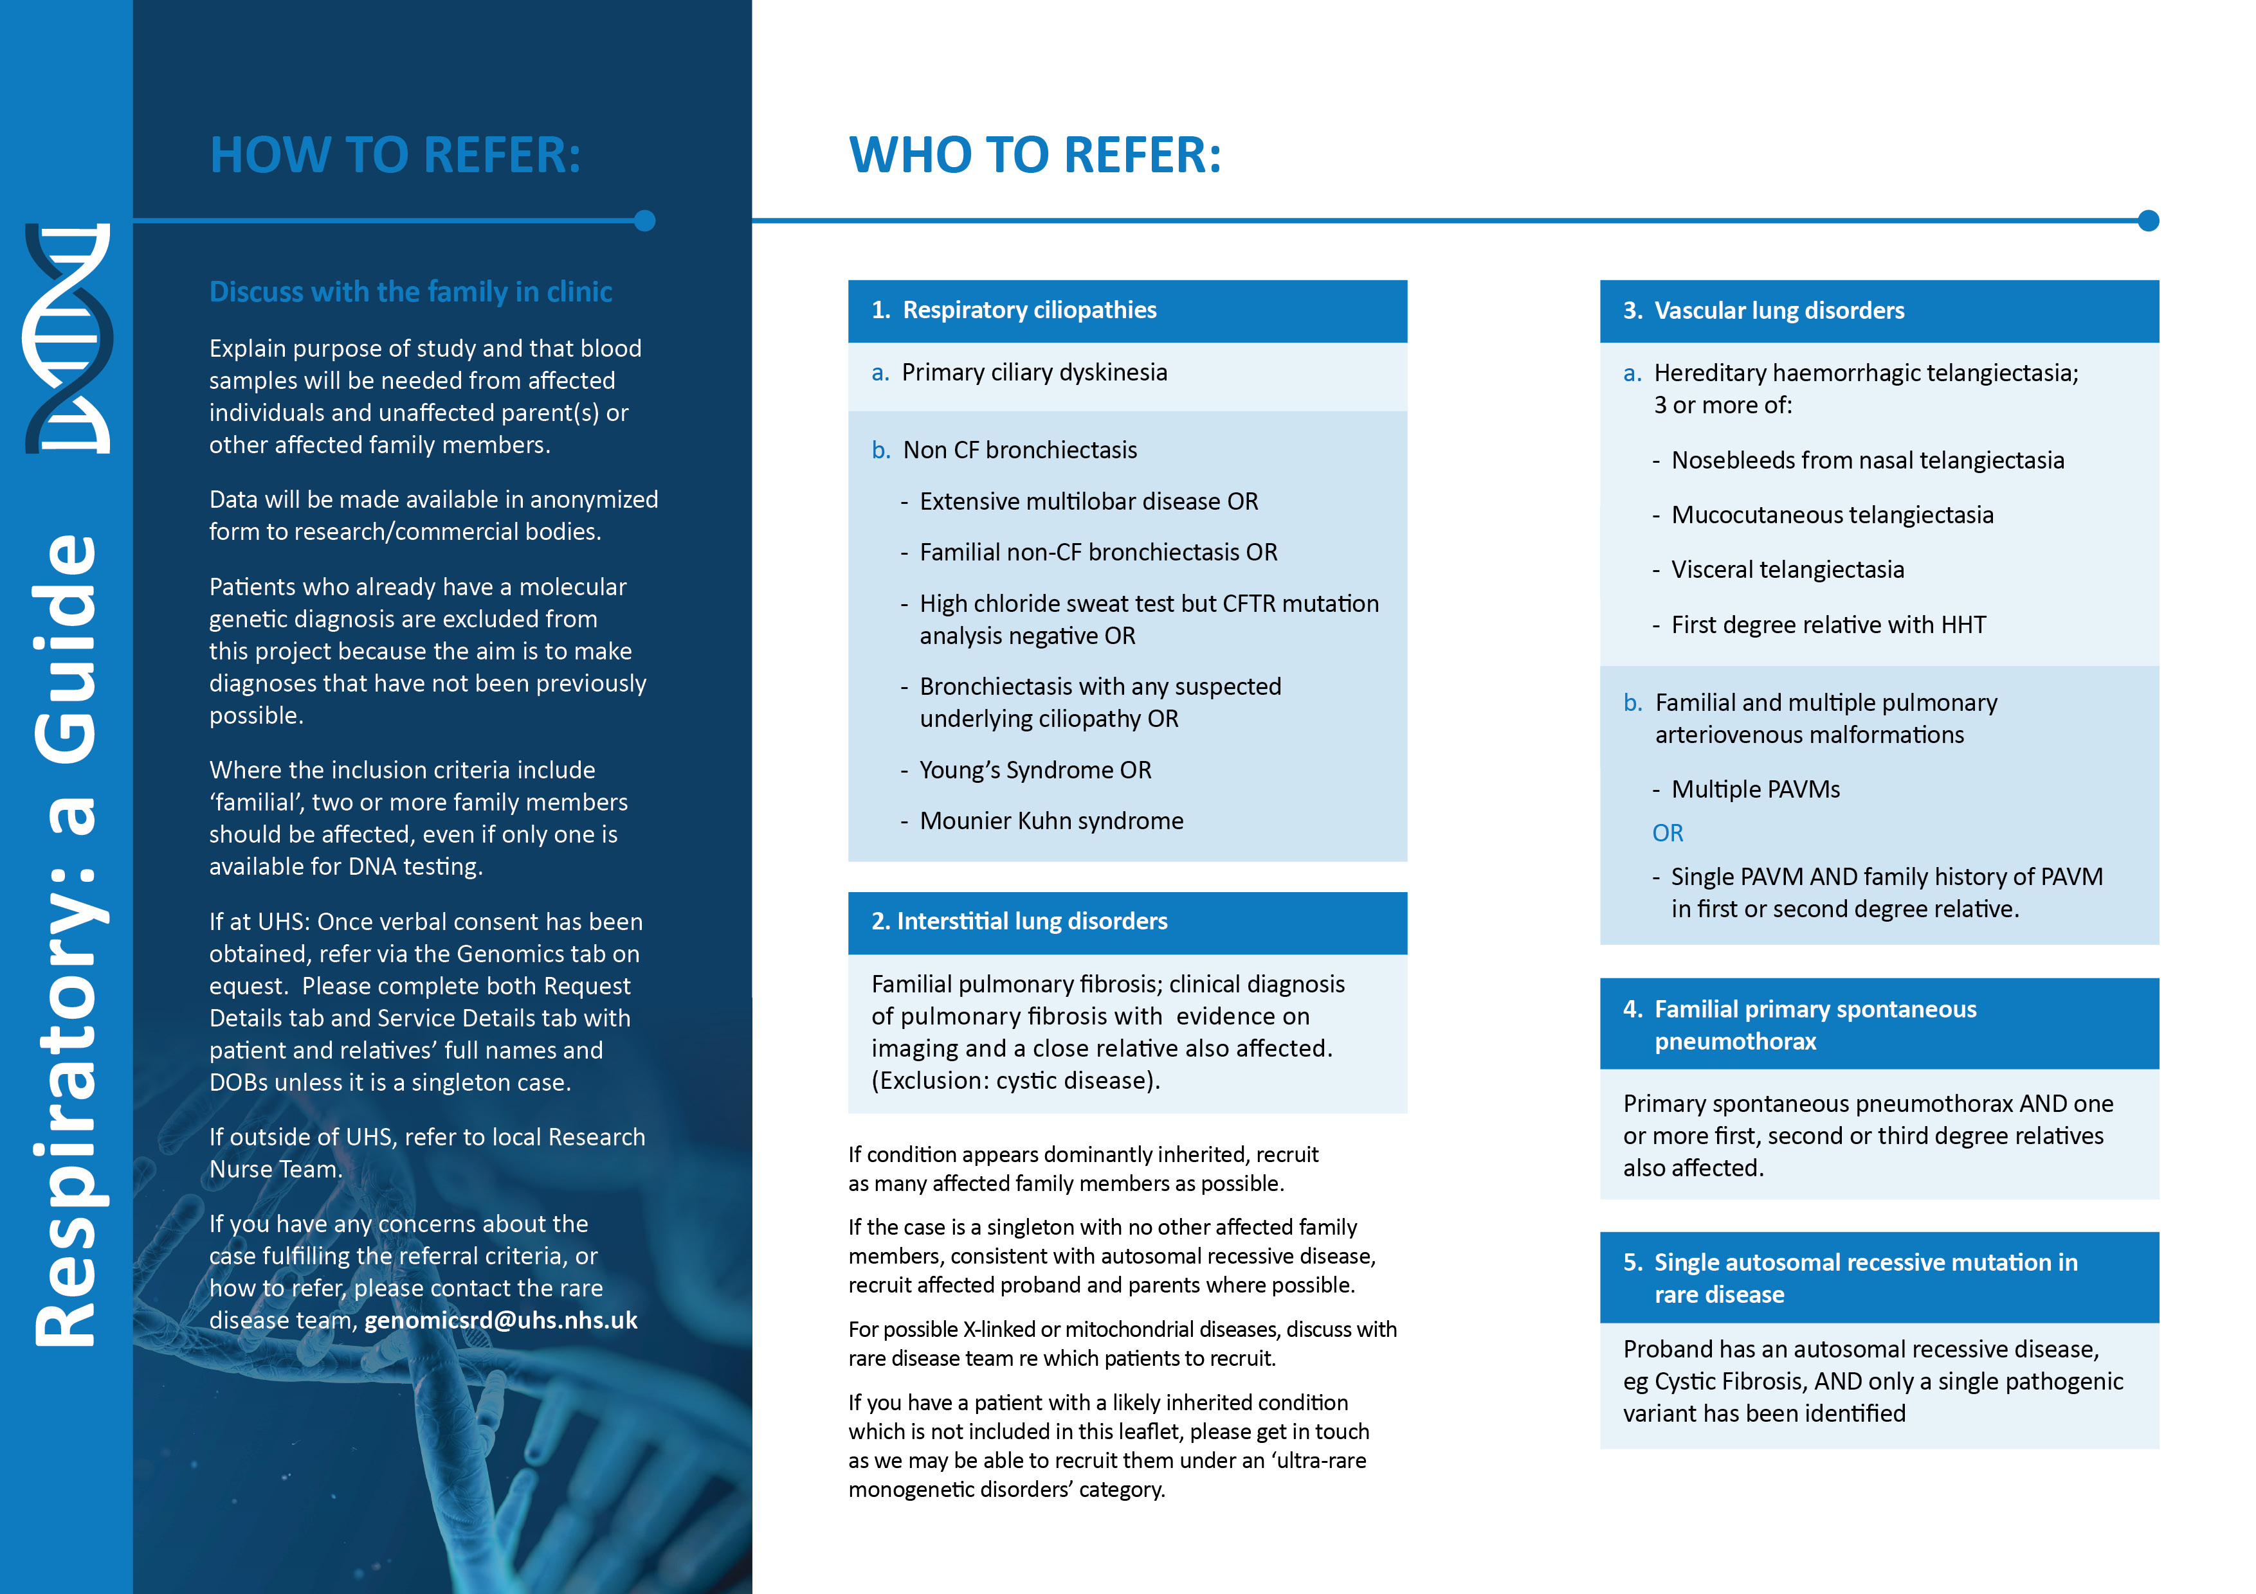

Describe local referral route here and local project team details